DESIGN AND DEVELOPMENT OF AN AUTONUMUS WATER BODIES CLEANING VEHICLE

ABSTRACT:

Water pollution caused by floating waste such as plastics and debris is a growing environmental concern. This project presents an autonomous water bodies cleaning vehicle designed to efficiently remove surface pollutants from rivers, lakes, and ponds. The system operates without human intervention using sensors and programmed control for navigation and obstacle avoidance. It is equipped with a conveyor-based mechanism to collect and store waste onboard. The vehicle improves cleaning efficiency while reducing manual labour and time consumption. Integration of features like solar power and GPS enhances sustainability and performance. This solution promotes cleaner water bodies and supports effective environmental management.

DESCRIPTION:

BACKGROUND OF THE INVENTION:

Water pollution has become a major global environmental challenge due to rapid urbanization, industrialization, and improper waste disposal practices. Large amounts of plastic waste, organic debris, and other floating pollutants accumulate in rivers, lakes, and ponds, leading to the degradation of aquatic ecosystems and posing serious risks to human health. According to organizations such as the World Health Organization and the United Nations Environment Programme, contaminated water bodies contribute to biodiversity loss and the spread of waterborne diseases.

Traditional cleaning methods mainly rely on manual labour, which is time-consuming, inefficient, and often hazardous for workers. In recent years, advancements in Robotics and Automation have enabled the development of autonomous systems capable of performing repetitive and risky tasks with higher efficiency. This has led researchers to explore innovative solutions such as unmanned surface vehicles for environmental monitoring and cleaning.

The need for a cost-effective, efficient, and sustainable cleaning system has motivated the investigation into an autonomous water bodies cleaning vehicle. Such a system can continuously monitor and remove waste with minimal human intervention, contributing to cleaner water environments and improved ecological balance.

SUMMARY OF THE INVENTION:

This investigation focuses on developing an autonomous solution to address the growing problem of water pollution caused by floating waste in rivers, lakes, and ponds. Traditional manual cleaning methods are inefficient, labour-intensive, and unsafe, highlighting the need for a smarter approach. By leveraging advancements in Robotics and Automation, the proposed system introduces an unmanned vehicle capable of navigating water surfaces, detecting obstacles, and collecting waste efficiently.

The study explores the design, working principles, and implementation of this vehicle, including key components such as sensors, propulsion systems, and waste collection mechanisms. Overall, the investigation demonstrates how autonomous technology can provide a sustainable, efficient, and scalable solution for maintaining clean water bodies and protecting the environment.

BRIEF DESCRIPTION OF THE DRAWINGS:
- FIG. 1: controlling system of the vehicle
- FIG. 2: belt for the waste collection
- FIG. 3: working model

DESCRIPTION OF PREFERRED EMBODIMENT:

The preferred embodiment of the autonomous water bodies cleaning vehicle is designed as a compact, unmanned surface vessel capable of efficiently removing floating waste from water bodies. The vehicle consists of a buoyant hull structure made from lightweight and corrosion-resistant materials, ensuring stability and durability in aquatic environments. It is powered by electric motors connected to propellers, enabling smooth navigation across the water surface.

The system integrates key technologies from Robotics and Embedded Systems to achieve autonomous operation. A microcontroller-based control unit processes inputs from sensors such as ultrasonic sensors for obstacle detection and GPS modules for navigation. These components allow the vehicle to move along predefined paths while avoiding collisions.

A conveyor belt or scoop mechanism is mounted at the front of the vehicle to collect floating debris such as plastics and organic waste. The collected waste is transferred into an onboard storage container, which can be periodically emptied. The propulsion and collection systems are synchronized to ensure continuous cleaning without interruption.

For improved efficiency and sustainability, the vehicle can be equipped with solar panels to supplement battery power, extending operational time. The entire system is designed to operate with minimal human intervention, reducing manual effort and increasing cleaning effectiveness. This embodiment provides a practical and scalable solution for maintaining cleaner water bodies and supporting environmental conservation efforts.

CLAIMS:
- An autonomous water bodies cleaning vehicle comprising a buoyant hull, a propulsion system, a waste collection mechanism, and a control unit configured to operate the vehicle without human intervention.
- The vehicle as claimed in Claim 1, wherein the propulsion system includes electric motors and propellers to enable movement across the water surface.
- The vehicle as claimed in Claim 1, wherein the control unit is based on an embedded system integrating technologies from Robotics and Embedded Systems for autonomous navigation.
- The vehicle as claimed in Claim 1, further comprising sensors including ultrasonic sensors for obstacle detection and navigation.
- The vehicle as claimed in Claim 1, wherein a GPS module is used to guide the vehicle along predefined paths and monitor its position.
- The vehicle as claimed in Claim 1, wherein the waste collection mechanism comprises a conveyor belt or scooping arrangement configured to collect floating debris from the water surface.
- The vehicle as claimed in Claim 6, wherein the collected waste is transferred into an onboard storage container for later disposal.
- The vehicle as claimed in Claim 1, further comprising a renewable energy source, including solar panels, for extending operational time.
- The vehicle as claimed in Claim 1, wherein the hull is constructed from lightweight, corrosion-resistant materials to ensure durability and stability.
- The vehicle as claimed in Claim 1, wherein the system is configured for continuous monitoring and cleaning of water bodies with minimal human intervention.
- The vehicle as claimed in Claim 1, wherein the control unit is programmed to optimize navigation routes and improve cleaning efficiency.
- The vehicle as claimed in Claim 1, wherein the vehicle is adaptable for use in different types of water bodies including rivers, lakes, and ponds.

FIGURES:
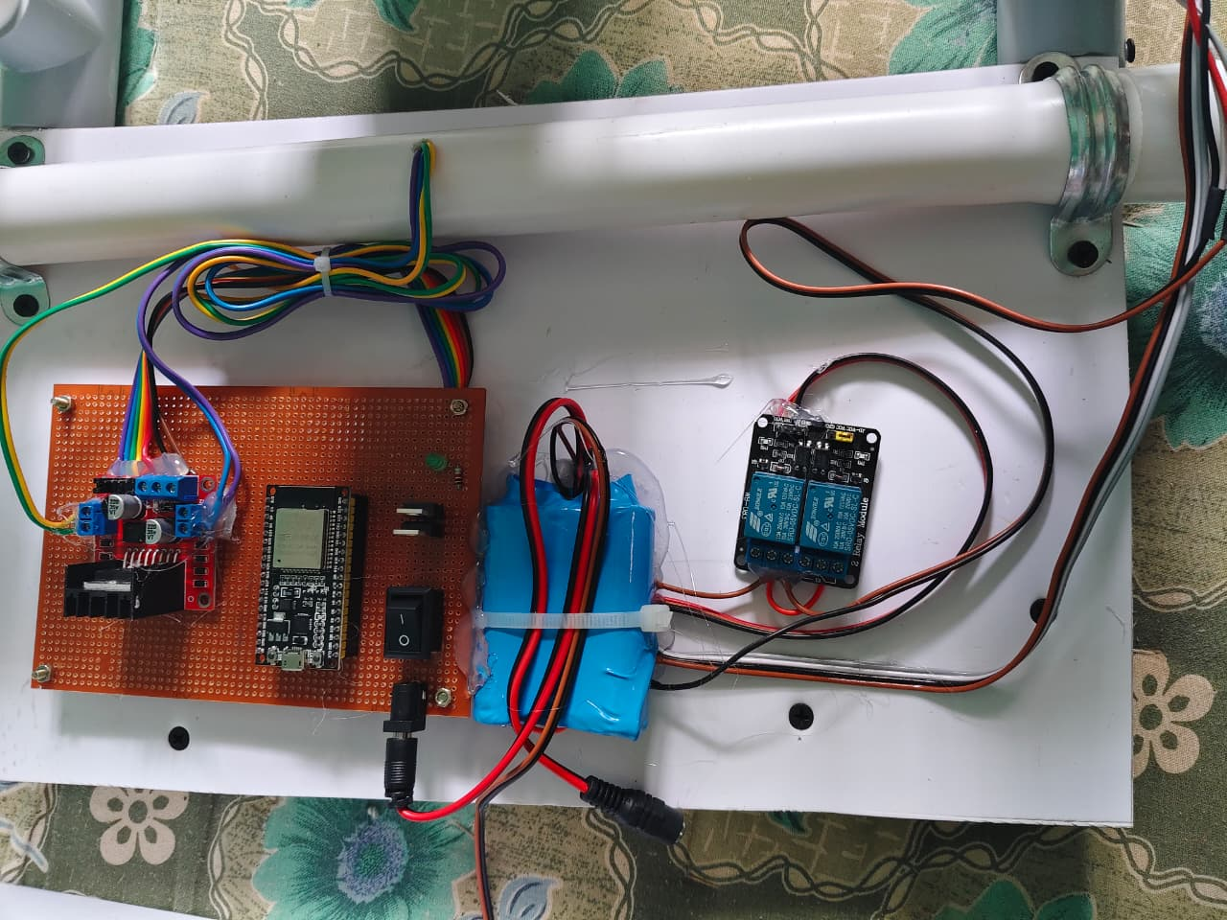
Fig 1.
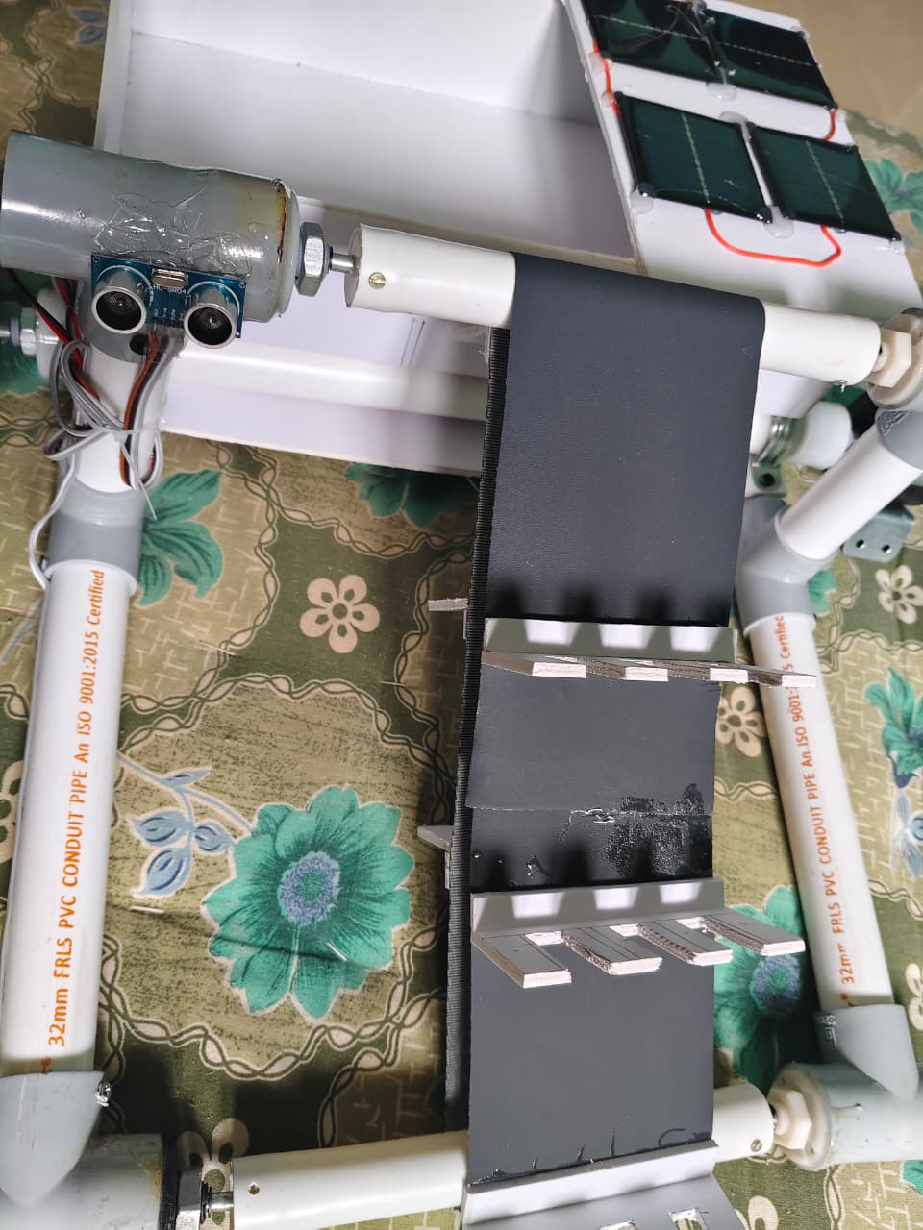
Fig 2.
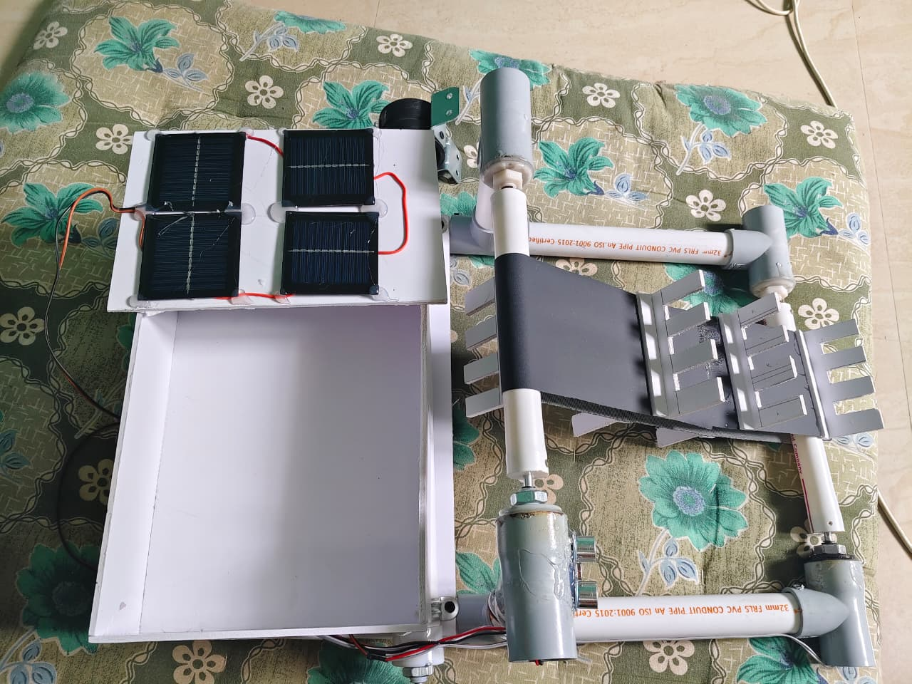
Fig 3.

